

Final Document.

***PRADS ZOO***

**Final Submission**

**2-October-2014**

2014

**CERTIFICATE OF COMPLETION**

**This Certificate is presented to**

**OWAIS AHMED SIDDIQUI**

**ALI NAWAZ**

**MUHAMMAD SHAFI**

**MUHAMMAD SAMMER**

**Has successfully designed a website on**

**PRADS ZOO**

During E-Project of CPISM

(1st Semester)

**APTECH** Worldwide Computer Education

Metro Star gate Center Karachi**.**

# ACKNOWLEDGMENT

We are thankful to almighty, ALLAHfor his grace and mercy to give us strength and ability to make us complete this e-Project website. We hereby present our project on ‘PRADS ZOO’.

We have tried our best to take all relevant and important topics in consideration so that this project may become more effective & a better outlook to come. This project has been developed with the help of ‘HTML /CSS / Java Script/Photoshop’.

We earnestly hope that this project will provide all the necessary information required for the user to fulfill their requirement. However, suggestions for improvement of the project will be thankfully acknowledged.

# PREFACE

First of all, we would like to thank ALLAH the Almighty, who gave us mind to think and heart to feel creativity & creation depends on thinking.

I would like to thank all the faculty members of Aptech. Very special thanks to our teacher SIR SHAH NAWAZ KHAN JADOON of APTECH for his expert advice and brilliant suggestions and always encouraged us to do the best. Indeed some class fellows are very important and we would like to thank all of them for their kind appreciation, encouragement and moral support.

We would also like to express our deepest gratitude to our parents whose well wishes enabled us to transform our dream into a reality.

Finally our sincere thanks to our teacher SIR SHAHNAWAZ KHAN JADOON for all their assistance in making this concept a reality.

**Problem Statement**

PRADS ZOO is one of the biggest zoo in the town. The land area of the zoo is 33 acres. PRADS ZOO was established in the year 1980 with 10 acre land but lately it was modified and land area was also added in the year 2000. Proper residing space for all the type of animals has been made and maintains human security at high rate. Proper supply of food for all the animals is maintained and checked at regular intervals. You need to develop a website for the PRADS zoo which will provide the information about all the animals (like species, animal classification) which are kept and along with their image.

**Requirement Specification:**

The Web site is to be created based on the following requirements.

1. The Home Page should be created making use of with a suitable logo
2. The look and feel of the project must be made user friendly and uniformity in the color combination must be maintained.
3. About us, Contact Us (address and map) must be added.
4. Animal’s information can be added in the categorized like birds, animals, water animals, and so on.
5. Safari option is there for which dummy booking option can be added.
6. Gallery of animals and birds must be added in the website.
7. Timings of the zoo must be added.
8. Navigation of the project must be made smooth.
9. Events organized (Informative for audience and for the welfare of the animals) must be noted.
10. Feedback and query can be added in the website.

# TABLE OF CONTENT

# Certificate of Completion

# Acknowledgment

# Preface

# Problem Statement

# Hardware Requirements

# Software Requirements

# Task Sheet

# Developer Guide

# Snap Shots

# 

# 

# HARDWARE/ SOFTWARE REQUIREMENTS

# Hardware

* A minimum computer system that will help you access all the tools in the courses is a Pentium 166 or better
* 64 Megabytes of RAM or better

# Software

* Notepad/HTML editor
* Dreamweaver
* IE 5.0/ Netscape 6.0

# DEVELOPER GUIDE

* Our strength is the design of our web page, it has a professional look & feel and User can access any page of our website easily.
* We have a unique MENU which contains various pages of our website.
* We have a special type of Contact Us Page which contains not only the contact information, but a form, by filling which, the user can give Suggestions
* We have developed the whole website on DIVs & Tables are used only for tabular form of data which had to be entered in our website.
* Our Website is cross browser compatible.
* We have given download links on our product pages so that customers of ‘PRADS ZOO’ products can download price lists of the given products in Docx or PDF Files.

**Task Sheet**

|  |  |  |  |  |  |
| --- | --- | --- | --- | --- | --- |
| ***Sr*** | ***Task*** | ***Actual Starting Days*** | ***Actual Days*** | ***Group Members*** | ***Status*** |
| **1** | Data  Collecting | 11-Sep-2014 | 2 | Owais Ahmed  Ali Nawaz  M.Shafi  M.Sammer | Completed |
| **2** | Making Logo | 13-Sep-2014 | 1 | Owais Ahmed  Ali Nawaz | Completed |
| **3** | HTML/CSS/JavaScript | 14-Sep-2014 | 5 | Owais Ahmed  Ali Nawaz  M.Shafi  M.Sammer | Completed |
| **4** | Connecting Links | 19-Sep-2014 | 2 | Owais Ahmed  Ali Nawaz | Completed |
| **5** | Making Docx & Pdf Files & Slider | 23-Sep-2014 | 2 | Owais Ahmed  Ali Nawaz | Completed |
| **6** | Website Testing | 25-Sep-2014 | 1 | Owais Ahmed  Ali Nawaz  M.Shafi  M.Sammer | Completed |
| **7** | Documentation | 25-Sep-2014 | 1 | Ali Nawaz  Owais Ahmed | Completed |

SNAPSHOTS

# HOME

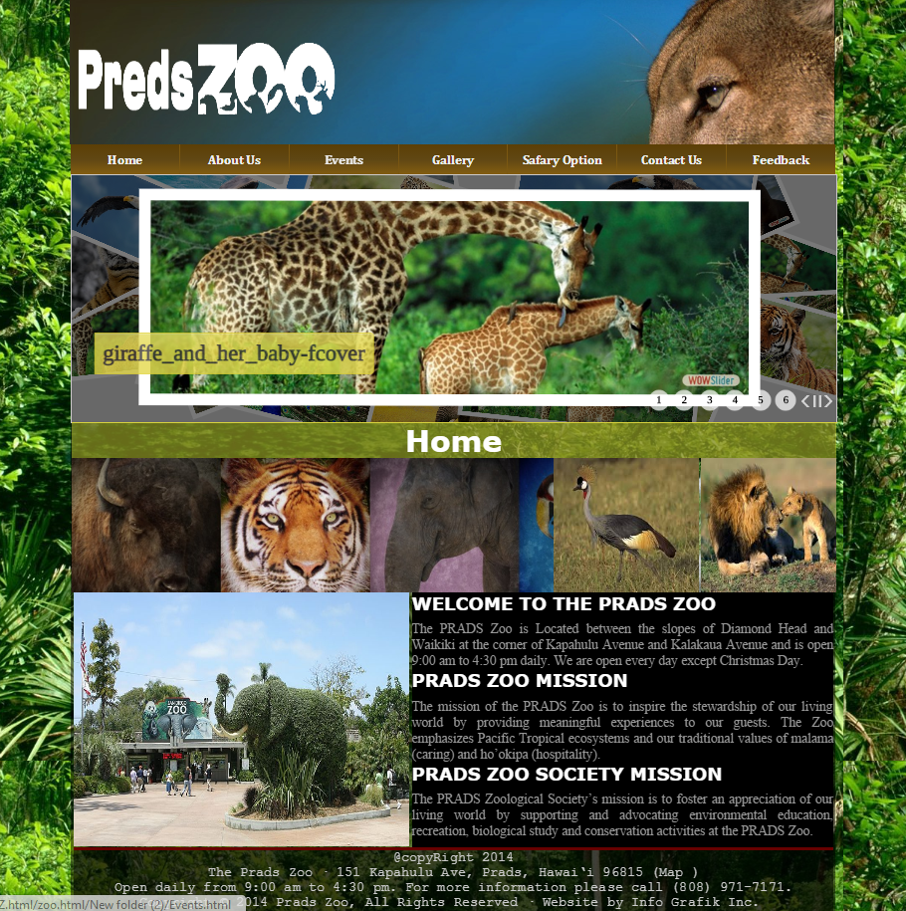

# SNAPSHOTS

# SNAPSHOTS

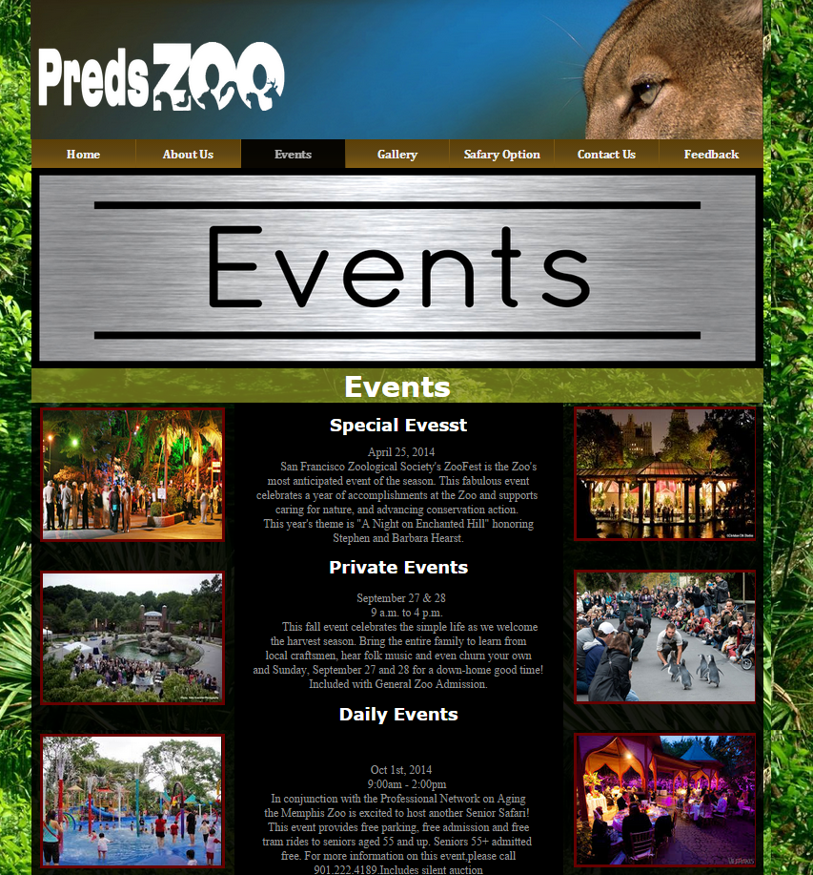

SNAPSHOT

SAFARI OPTION

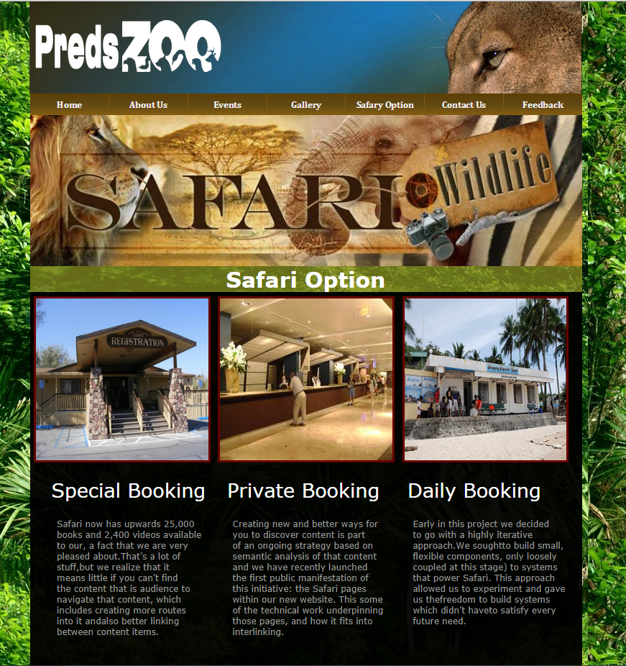

**THANK YOU**

**For Your Precious Time**